Project title: Enhancing global explainability and reducing explanation latency in phishing email detection
Group 4 – Monday 13:00
Team members: Luu Tran (14522561), Xuxian Lu (25701855), Hooward Kangdrew (25008970), ​
Thien Bao Minh Dang (14512584), Viet Anh Pham (14515011)

- Project description including: Aims, significance, and expected outcome of the project.

As the digital world is evolving, cyber-crime especially email phishing is a threat to the internet users. Current techniques to detect phishing are primarily based on machine learning models that are reliable in terms of accuracy, however, it’s trustworthy is not definite. Sarker et al. (2024) stated that the transparency of the model contributes to its worthiness and accountability. Philips et al. (2020) also reinforce the importance as an intelligence system needs to be explainable, meaningful, reflect on its output and acknowledge it’s limitation. Hence a global explanation of a model can gain trust from businesses, customers, help diagnose incidents, and acknowledge its weak points. This assists the models to aligns with the principles identified in Philip et al. (2020).
However, current techniques of explainable AI study on email phishing detection models are only interpret for single email. This helps the model responsible for its own output, but it does not directly help the model meaningful overall. Moreover, the latency can be a pain point since current techniques requires expensive operations.
Therefore, our project aims to uncover the black-box nature of the models by giving a global explanation and reduce the latency to compute explanation for individual email.
We hypothesize that a there exist a global explainable surrogate model that can approximate the original model with high fidelity that it can be used to explain the original model. Furthermore, the latency to compute explanation for an example would be faster than current methods. Choices for surrogate model can be Explainable Boosting Machines (EBM) or Generalize Additive Model (GAM).
It is expected that an evaluation of the proposed methods on trained email phishing detection models would be produced. Based on the results, global explanations for each model will be given. Finally, explanation latency will be benchmarked against existing methods.

- Related work

Techniques to explain email phishing detection models

Traditional machine learning algorithms has been widely used to detect phishing emails. Safi and Singh (2023) analysed that different machine learning algorithms dominants in email phishing detection methods. Algorithms such as Random Forest, Support Vector Machine or Multi-layer Perceptron are identified to be studied in vast number of studies. However, Radulovic et al. (2021) argues that machine learning model such as Random Forest and Neural Networks are a black-box classifiers. Current techniques for explaining phishing email detection model shown in table 1 and Sharma et al. (2025) shown that LIME and SHAP are two most common methods to explain a black box model in cybersecurity, specifically email phishing. However, these methods are mainly classified as local post-hoc methods (Hassija et al., 2023), meaning they explain individual predictions rather than the model as a whole. Therefore, global explainable AI methods for phishing emails are under-explored.
Authors | Title | XAI methods | AI models
Al-Subaiey et al. (2024) | Novel interpretable and robust web-based AI platform for phishing email detection | LIME | Support Vector Machine, Multinomial Naive Bayes, Random Forest Classifier
Al-E'mari et al.(2025) | A Cognitive BDI–BiLSTM Hybrid Framework for Interpretable Email Threat Detection | SHAP, Belief–Desire–Intention cognitive agent | Bidirectional Long Short-Term Memory
Shendkar et al. (2025) | Enhancing Phishing Attack Detection Using Explainable AI: Trends and Innovations | SHAP, Grad-CAM | Deep learning models
Uddin et al. (2026) | An Explainable Transformer-based Model for Phishing Email Detection: A Large Language Model Approach | LIME-Transformer Attribution | RoBERTa
Table 1. Literature Review on XAI methods for email phishing detection models

Global Post-hoc Model Agnostics Methods
There are several global post-hoc model agnostics methods that we can adopt to explain email phishing models. Friedman and Popescu (2008) used Rule Ensembles to build an intrinsically explainable models using if-then rules. However, if the complexity grows, interpretability can be reduced and it is instable. Apley and Zhu (2020) on the other hand used Accumulated Local Effects which accumulate small changes to observe changes in the predictions. However, the authors also state that it may be instable and does not scale well. Bastani et. al. (2019) used a decision tree as a global surrogate models to interpret the original models. However, the author also, pointed out the simple models such as decision tree may not fit well on the training data with low-depth tree. If the performance issue can improve, it can be potentially provided better trust.
Author | XAI method | Feasibility | Risk
(Apley & Zhu, 2020) | Accumulated Local Effects | Computationally Efficient and Truly Mathematical explanation | Complex  interpretations
(Friedman & Popescu, 2008) | Rue Ensembles | Human-Readable Logic | Linear Assumption and sensitive to threshold
Bastani et. al. (2019) | Global surrogate model | Highly interpretable | May not fit the original model well
Table 2. Literature Review on Global Post-hoc XAI methods.

Glass-box models
To address the under-fitting problem of simple global surrogate models. Alternative choices for global surrogate models can be adopted. Generlized Additive Models (GAM) is a family of additive models that can be interpretable and visualized (Wood, 2017). This family of models have high potential as they may perform better than low-depth tree or logistic regression yet remain interpretable.
If implemented successfully, existing explanations for email phishing detection model would be more faithful and more transparent at a global level. Furthermore, contribution to global surrogate models can be robust and reliable.

- Feasibility study in terms of computing & time resources, team’s capability, and skill sets.
This research is considered feasible with respect to computing resources, time constraints, and the technical capabilities of the project team. The study leverages publicly available datasets and accessible machine learning tools, ensuring that both implementation and evaluation can be conducted within the available project scope.
From a data availability perspective, the research utilises well-established public email corpora, including the Nazario Phishing Corpus (Nazario, 2007), the Enron Email Dataset (Cohen, 2015), and multiple Kaggle phishing datasets (Kaggle, 2024). These datasets provide a reliable and diverse foundation for constructing a business-oriented dataset of approximately 40,000 to 80,000 emails. The combination of phishing and legitimate emails ensures sufficient variability for training and evaluating classification models, while also supporting the generalisability of results across different organisational contexts.
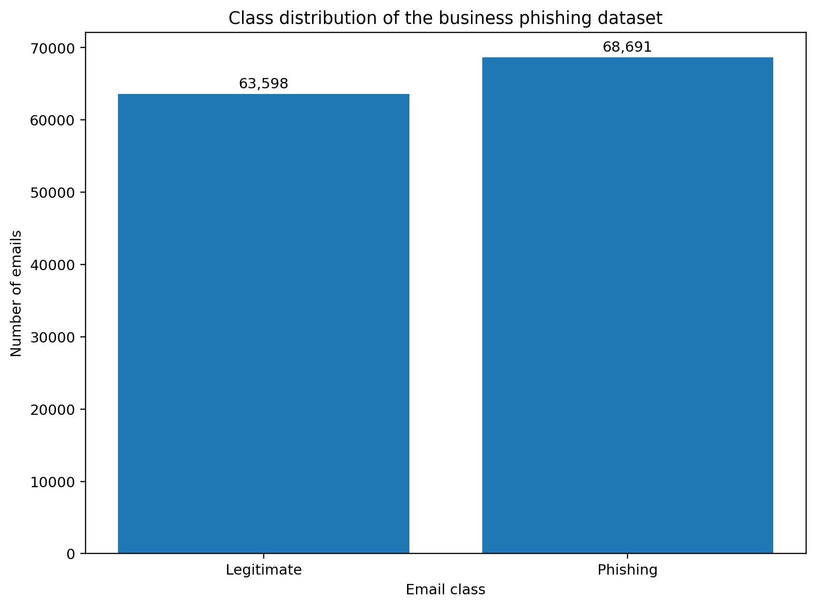
Figure 1: Class Distribution of the business phishing dataset chart

In terms of computing resources, the project relies on local machines owned by team members. These systems are capable of running Python-based machine learning workflows using widely adopted open-source libraries such as scikit-learn, pandas, and SHAP. The computational requirements of the study primarily involving data preprocessing, feature engineering, model training, and explainability analysis are manageable on standard modern laptops without the need for specialised hardware such as GPUs or cloud-based infrastructure. Additionally, optimisation strategies such as sampling and feature selection can be employed to ensure efficient execution within the given timeframe.
The research workflow consists of several stages, including data cleaning, preprocessing, feature extraction, model training, and explainability evaluation. Traditional machine learning models will be developed for phishing detection, followed by the application of interpretable surrogate models such as GAMI-Net or Explainable Boosting Machines (EBM). These models will approximate the behaviour of the primary classifier and provide interpretable insights into feature importance and decision-making processes. The evaluation phase will assess both predictive performance and explanation quality using standard metrics such as precision, recall, F1-score, and explanation fidelity.

Figure 2: Overview of the Proposed Phishing Detection and Explainability Comparison Pipeline

Regarding team capability, all members possess relevant academic backgrounds in computing science, with exposure to machine learning, data analysis, and cybersecurity concepts. This multidisciplinary skill set supports effective collaboration across different stages of the project, from data engineering to model evaluation. The team’s prior experience with Python programming and structured data processing further strengthens the feasibility of successfully implementing the proposed methodology within the allocated timeframe.
Finally, ethical considerations have been incorporated into the research design. All datasets used are publicly available and anonymised, ensuring that no personally identifiable or sensitive information is exposed. The study adheres to responsible data usage practices and aims to minimise potential biases in both model training and evaluation.
- Project management plan
This project is planned over 12 weeks, the whole project has distributed into clear milestones, have discussed and agreed with the team. In week 1-2, the team focused on finding the research area and defining the research problem to clarifying the project scope. In week 3-4, team have decided the research topic, and share the instructions with the group members, schedule weekly meeting to ensure every team member have up to date with the project. In week 5, our team collect suitable datasets, conduct data preprocessing process and start preparing the code for testing the selected methods for the project. Week 6-7, the team complete the code testing, ran the model with the test dataset and output the result, able to compare the current model with the baseline model with better result. Output diagram to visualize the result to prepare for the project presentation. During the Stuvac, the team have conducted two meetings to ensure the team member have a clear understanding of the topic meanwhile, prepare the team for individual presentation. In week 8, the project was presented and explained to other groups for feedback and answer Q&A after the presentation. From week 9 onwards, the focus of the team is to refining the solution, improving the performance of the solution, and improving the report for the final submission.
Luu Tran is the group leader, responsible for progress checking of the project. Xuxian Lu and Viet Anh Pham are responsible for the literature review section for this project. Hooward Kangdrew is responsible for data collection and preprocessing for the model and Thien Bao Minh Dang is responsible for preparing the code environment for the model testing. No financial budget is required because the project uses Python, GitHub, Microsoft Teams, Overleaf, local computing resources and public available datasets.
Key risk of this project includes data imbalance, bad model performance, lack of publicly available datasets, lack of computing resources and real-world performance issues. Data imbalance issue can be resolved by up sampling methods or reducing samples from one class. Model performance is the key challenge because, although it is predicted to perform well, problem such as program unexpected behaviour such as numerical instability can be an issue. To address that we can consider lower precision points. Computing resources are predicted to be enough, but cloud computing can be a back-up solution.
Discord is used for the main communication tool in the team; the project information and updates are shared in group chat. Zoom is used for hosting the weekly meeting on every Saturday at 1pm, if there is additional meeting for the week, information will be sent on discord in advance, weekly meeting is used to share information and checking progress of the project, to ensure everyone is on track to the project and resolve the issues efficiently.

- References
Abdulla Al-Subaiey, Al-Thani, M., Naser Abdullah Alam, Kaniz Fatema Antora, Amith Khandakar, & SM. (2024). Novel interpretable and robust web-based AI platform for phishing email detection. Computers & Electrical Engineering, 120, 109625–109625. https://doi.org/10.1016/j.compeleceng.2024.109625​
Al-E’Mari, S., Sanjalawe, Y., Fraihat, S., Kurdi, G., & Allehyani, B. (2025). A Cognitive BDI–BiLSTM Hybrid Framework for Interpretable Email Threat Detection. IEEE Access, 1–1. https://doi.org/10.1109/access.2025.3641123​
Apley, D. W., & Zhu, J. (2020). Visualizing the effects of predictor variables in black box supervised learning models. Journal of the Royal Statistical Society. Series B (Statistical Methodology), 82(4), 1059–1086. JSTOR. https://doi.org/10.2307/26937906​
Bastani, H., Bastani, O., & Kim, C. (2018). Interpreting predictive models for human-in-the-loop analytics
Cohen, W. W. (2015). Enron email dataset. Carnegie Mellon University.
https://www.cs.cmu.edu/~enron/
Friedman, J. H., & Popescu, B. E. (2008). Predictive learning via rule ensembles. The Annals of Applied Statistics, 2(3), 916–954. https://doi.org/10.1214/07-aoas148​
Greco, F., Desolda, G., & Esposito, A. (2023). Explaining Phishing Attacks: An XAI Approach to Enhance User Awareness and Trust. https://ceur-ws.org/Vol-3488/paper22.pdf​
Hassija, V., Chamola, V., Mahapatra, A., Singal, A., Goel, D., Huang, K., Scardapane, S., Spinelli, I., Mahmud, M., & Hussain, A. (2023). Interpreting Black-Box Models: a Review on Explainable Artificial Intelligence. Cognitive Computation, 16(1), 45–74. https://doi.org/10.1007/s12559-023-10179-8​
Kaggle. (2024). Phishing email dataset. Kaggle.
https://www.kaggle.com/
Nazario, J. (2007). Phishing corpus.
http://monkey.org/~jose/phishing/
Phillips, P. J., Hahn, C. A., Fontana, P. C., Broniatowski, D. A., & Przybocki, M. A. (2020, August). Four principles of explainable artificial intelli- gence (NIST Interagency/Internal Report No. NIST.IR.8312-draft). Na- tional Institute of Standards and Technology. Gaithersburg, MD. https://doi.org/10.6028/NIST.IR.8312-draft
Radulovic, N., Bifet, A., & Suchanek, F. M. (2021). Confident interpretations of black box classifiers. 2021 International Joint Conference on Neural Networks (IJCNN), 1–8. https://doi.org/10.1109/IJCNN52387.2021. 9534234
Safi, A., & Singh, S. (2023). A systematic literature review on phishing website detection techniques. Journal of King Saud University - Computer and Information Sciences, 35 (2), 590–611. https://doi.org/10.1016/j.jksuci. 2023.01.004
Sarker, I. H., Janicke, H., Mohsin, A., Gill, A., & Maglaras, L. (2024). Explainable AI for cybersecurity automation, intelligence and trustworthiness in digital twin: Methods, taxonomy, challenges and prospects. ICT Express, 10(4). https://doi.org/10.1016/j.icte.2024.05.007​
Sharma, A., Rani, S., & Shabaz, M. (2025). A comprehensive review of explainable AI in cybersecurity: Decoding the black box. ICT Express. https://doi.org/10.1016/j.icte.2025.10.004​
Shendkar, B. D., Chandre, P. R., Sulochana Sagar Madachane, Kulkarni, N., & Deshmukh, S. (2024). Enhancing Phishing Attack Detection Using Explainable AI: Trends and Innovations. ASEAN Journal on Science and Technology for Development, 42(1). https://doi.org/10.61931/2224-9028.1604​
Uddin, M. A., Mahiuddin, M., & Sarker, I. H. (2026). An explainable transformer-based model for phishing email detection: A large language model approach. Computer Networks, 277, 112061. https://doi.org/10.1016/j.comnet.2026.112061
Wood, S. N. (2017). Generalized additive models: An introduction with r (2nd ed.). Chapman; Hall/CRC. https://doi.org/10.1201/9781315370279

